**“DEVELOPMENT & CHARACTERIZATION OF PVA/STARCH NANOCOMPOSITE FILM USING NANOCELLULOSE”**

**Anurag Singh1, Mayur2**

**1Department Plastic engineering, Central institute of Petrochemicals engineering and Technology Lucknow**

**2Department Plastic engineering, Central institute of Petrochemicals engineering and Technology Lucknow**

**Mailing Address- asanuragsingh875@gmail.com**

**Mobile no. 7985226424**

**ABSTRACT**

Petroleum-derived synthetic polymers have become the material of choice for food packaging due to their ease of processing and low production costs. However, these polymers are non-biodegradable in nature, which causes a slew of issues with waste management. Biodegradable materials are desperately needed. The use of agricultural waste such as sugarcane bagasse, cassava peel, waste seed oil, and so on. Although starch is a common natural raw material that is already employed in a range of commercial applications, its utilization in bioplastic synthesis has shown potential. Despite the fact that starch is a common natural raw material that is already employed in a range of commercial applications, its usage in bioplastic synthesis has shown potential. Starch is renewable, biodegradable, and abundant material for producing biodegradable polymers. PVA is a water-soluble polymer with remarkable emulsifying, adhesive, and film-forming properties. Cassava peels contain a high concentration of starch, which is biodegradable, inexpensive, and abundant as a polysaccharide molecule. The present work is aimed to isolate the Nanocellulose and starch from waste cotton and cassava peel and further it is dispersed in varied proportions with Polyvinyl Alcohol (PVA) to produce biodegradable film by solvent casting method. The effect of different parameter i.e., mechanical, and thermal properties was studied for different compositions of blend films. The prepared blend film can find the application for food packaging, which is fully biodegradable in nature. Hence this factor has prompt current research focused in developing biodegradable materials targeted towards environmental sustainability

**Keywords:** Cassava peel, Polysaccharides, Starch, PVA, Composite film, Nanocellulose.

**1. Introduction**

Plastic materials are becoming more and more necessary these days, especially for food packaging. Packaging maintains the product's quality and shields it from the elements. To protect consumer safety, chemical migration from the packaging must be kept below the regulated safe level1. Otherwise, it could contaminate the food. The huge environmental impact that food packaging creates is also a problem and issue, as most of these products are not biodegradable or environmentally friendly. Polyvinyl alcohol (PVA) is increasingly being used in commercial sector across the globe. This is because of their distinctive chemical and physical characteristics, which also include the fact that they are nontoxic, highly crystalline, and water-soluble polymers, have good film-forming abilities, and have high hydrophilic qualities. PVA is also well known for being a biodegradable polymer. However, PVA's primary drawback is its high price, which is highly prohibitive. PVA can therefore be mixed. with other organic polymers to lower the cost of resources and make PVA more affordable to use. Since a PVA/starch blend would boost PVA's biodegradability, starch is one of the most often employed ingredients in PVA blends. It has been scientifically demonstrated through wide-ranging international investigations conducted by numerous researchers 2-5 Both starch and polyvinyl alcohol are polar molecules with hydroxyl groups in their chemical structures that can generate intermolecular and intramolecular hydrogen bonds 6. However, these PVA/starch blends' main drawbacks are their particularly poor water barrier qualities, which are typically attributable to the extremely high amount of hydroxyl groups and their inherent hydrophilicity. Nanofillers like nanosilicon dioxide7-8, montmorillonite clay9-10 , sodium montmorillonite clay11, and nanoparticles of poly(methyl methacrylate-co-acrylamide) have been the focus of the majority of earlier investigations12. However, the biodegradability of films was not significantly impacted by these nanoparticles. In order to improve the qualities of the PVA and starch blend by adding nanocellulose from EFB fiber as reinforcement, because nanocellulose has excellent mechanical properties. this research was carried out. In addition, compared to other fillers, very few investigations have been reported on the nanocellulose reinforced PVA/starch blend films. The three basic components of natural fibers are cellulose, hemicellulose, and lignin. In general, the EFB fiber has a higher cellulose composition than coir, corn, bagasse, and kenaf fiber, with 40–50% cellulose, 20–30% hemicellulose, and 20–30% lignin with a moisture level of roughly 10-15%. In addition to being used for food packaging, polymer-based nanocomposites hold considerable promise for a variety of other industries, including the auto, aerospace, optoelectronics, and biomedical ones. They exhibit an exceptional combination of optical, electrical, thermal, magnetic, and other physico-chemical properties in addition to excellent mechanical properties comparable to composite reinforced with microsized fillers because of their nanoscale size features and high aspect ratio.

The purpose of this work was to isolate nanocellulose from cotton and starch from cassava peel and further it is dispersed in varied proportions with polyvinyl Alcohol (pva) to produce biodegradable film by solvent casting method. And also investigated how the characteristics of PVA/starch films were affected by the nanocellulose content, which was extracted from cotton powder.

**2.Materials and chemicals-**

Cassava was purchased from the local market of Lucknow, Uttar Pradesh., Cotton powder is obtained from seed of cotton plants (Gossypium herbacerum). Cotton was purchased from local market of Lucknow, Uttar Pradesh. Sodium hydroxide is utilized in the present work was purchased from LOBA Chemie Pvt. Ltd. Mumbai. It was 97% extra pure, white flakes, odorless and had melting point 318°C, molecular weight. 40.00g/mol, boiling point 139°C, density 2.13g/cm3, Sulphuric acid utilized in the current work was bought from Central Drug House Pvt. Ltd. New Delhi. It was liquid with assay (acid) 38-40% yellow, non-volatile, non-combustible and had molecular weight. 40.46g/mol, density @20°C 1.83g/cm3boiling point ≥10 Glycerol is taken in the current work was purchased from Bangalore fine chemicals Pvt. Ltd. It is colorless, odorless, viscous liquid having density 1.25g/cm3, molecular weight. 92.09, boiling point. 182°C, melting point. 20°C, PVA taken in the current work was purchased from Chemie Pvt. Ltd. It was colorless having molecular weight. 1,15000, density@ 1.269g/cm3, melting point. 200°C.

###### 2.1 Experimental methodology

###### 2.1.1 Isolation of starch from Cassava

###### Cassava was collected from nearby store. The peels are washing & weighed, and cutting into small pieces there after blended with distilled water The mixture was filtered using filter paper & collected into glass beaker. Filtrate of starch was kept for 24hrs. After that it was drying in an oven at 400C temp. for 24hrs. and then dried starch was collected 13. Figure 1 shows the process of isolation of starch from cassava.

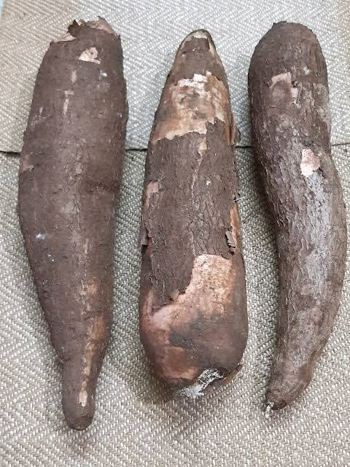 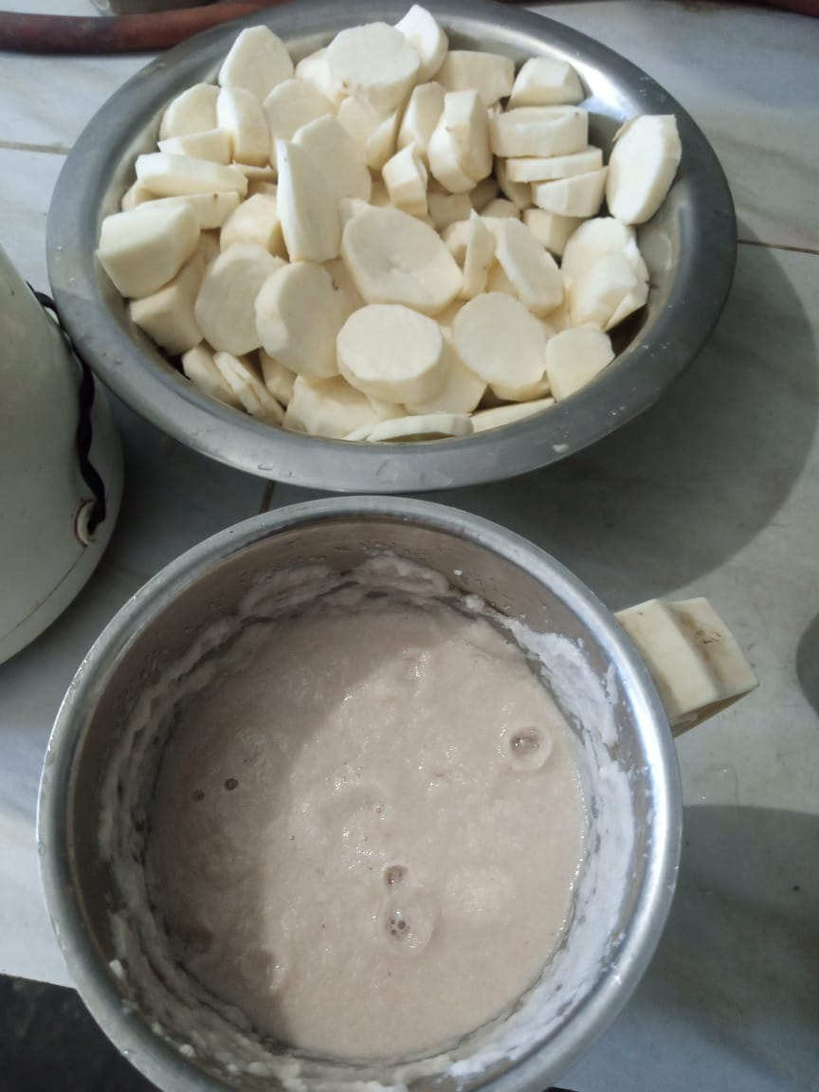 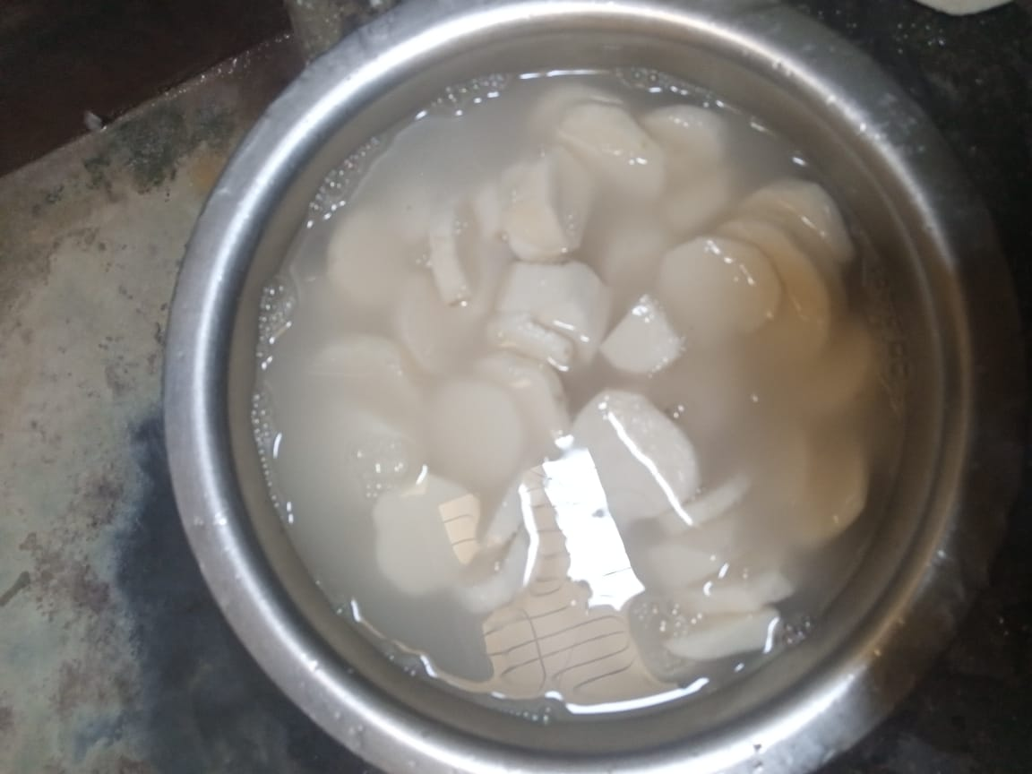 

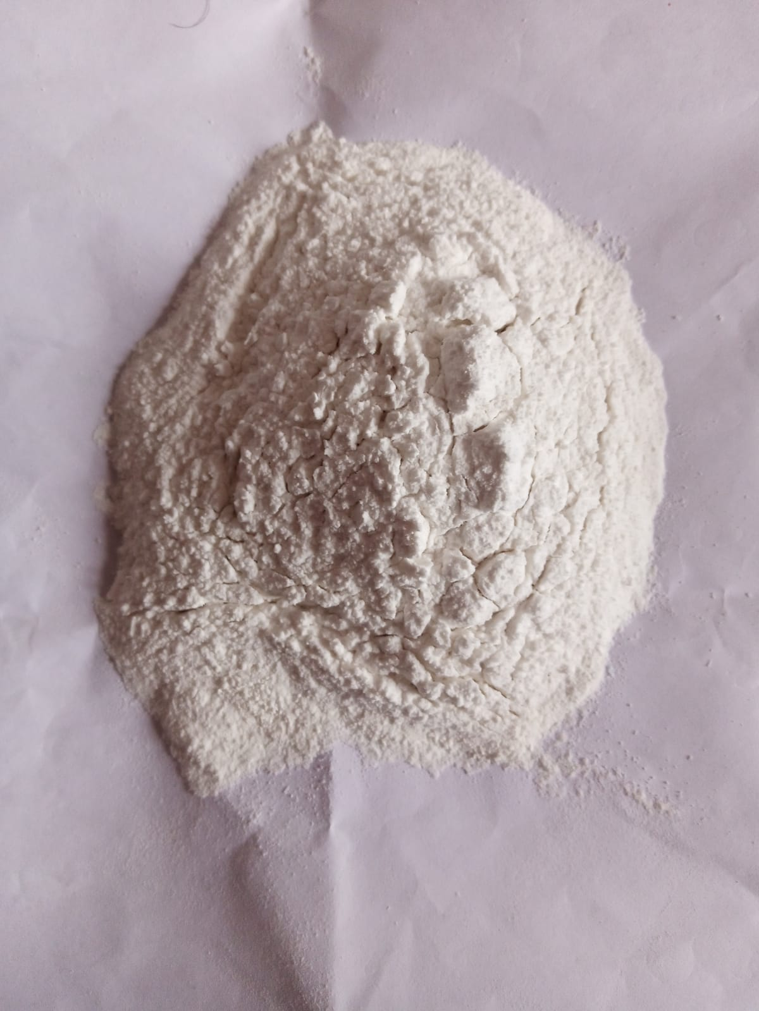 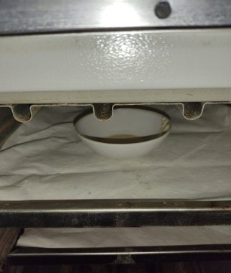

**Cassava Cutting Washing Grinding**

**Cassava starch Drying**

**Figure 1. Flow diagram of isolation method of Cassava starch**

###### 2.1.2 Isolation of Nanocellulose from cotton

###### Cotton was collected from nearby store of Lucknow. The isolation of nanocellulose was carried on two steps i.e., alkali treatment and acid hydrolysis method. Firstly, the cotton was made it in powder form and treated with 2% NaOH solution and blended it 5 min. then the filtrate wash with distilled water and dry it at 40°C. after that the powder treated with 5% H2SO4 by heated it at 30°C for half an hour. After that washed it with distilled water to maintain its PH. The mixture was filtered using filter paper & collected into glass beaker. Filtrate of Nanocellulose was kept for 24hrs. After that drying in an oven at 50°C temperature for 24hrs. and then dried nano cellulose was collected14. Figure.2 shows the process of isolation of nanocellulose from cotton.

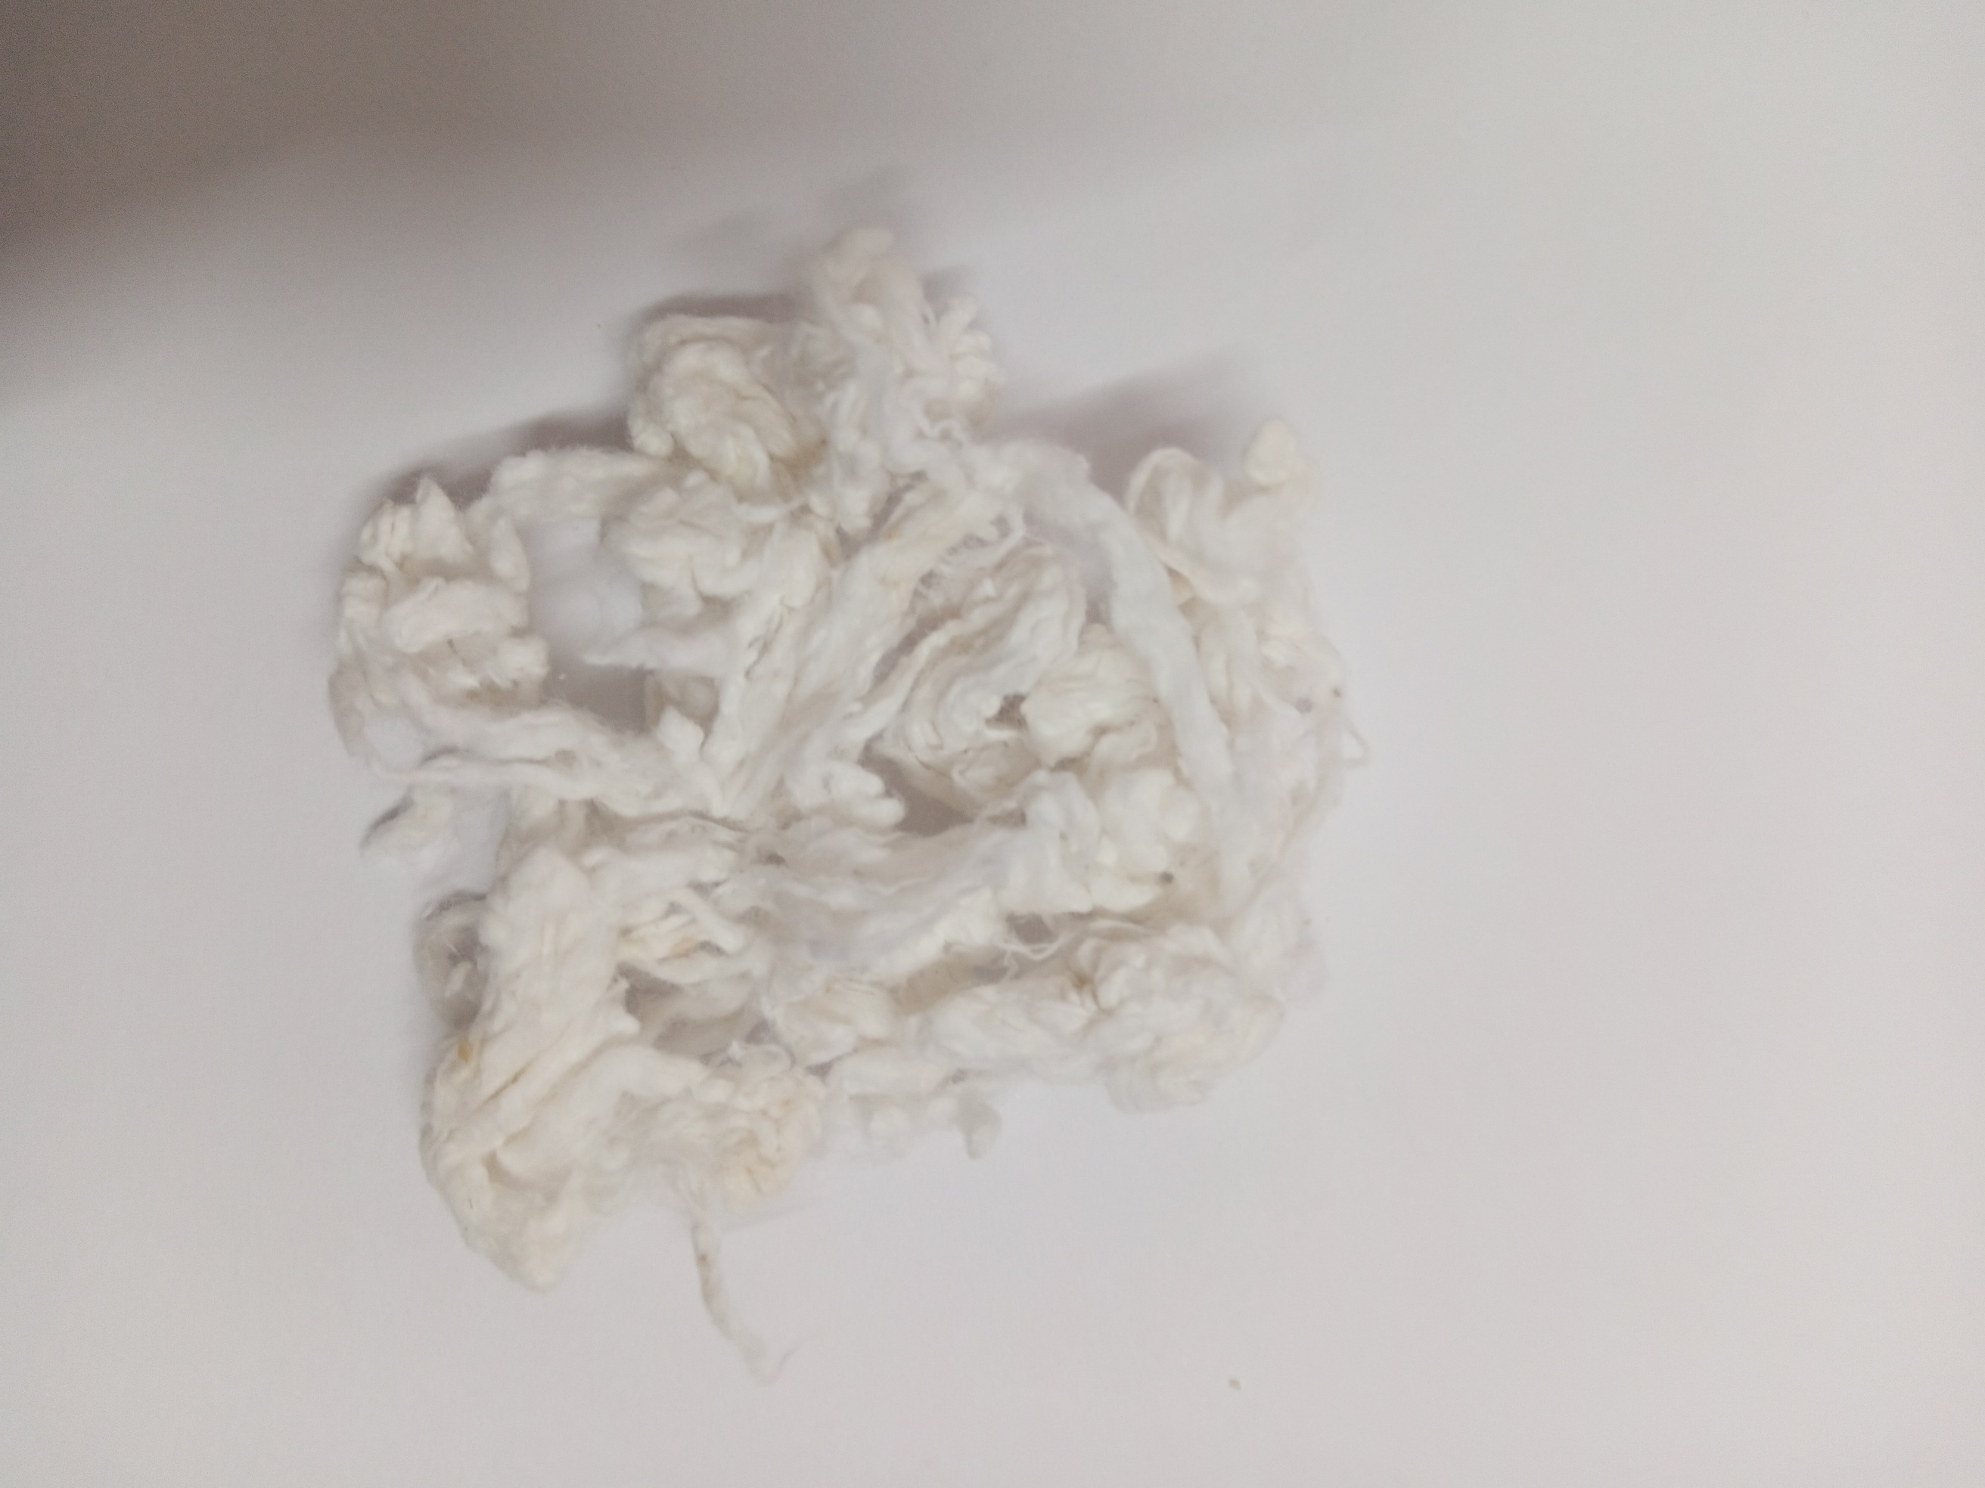 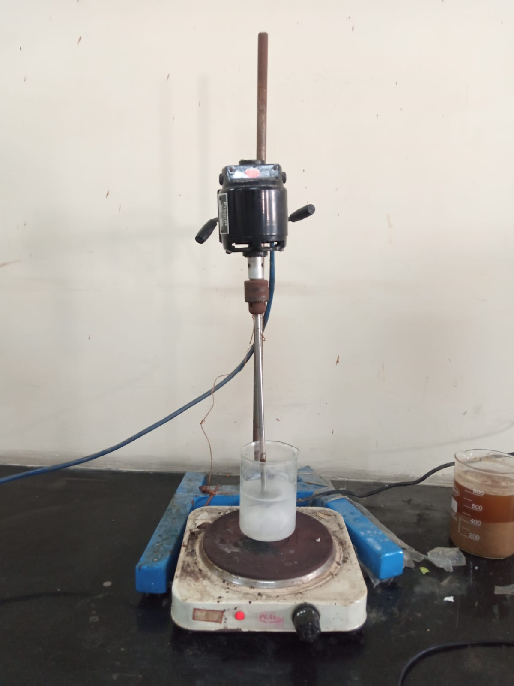 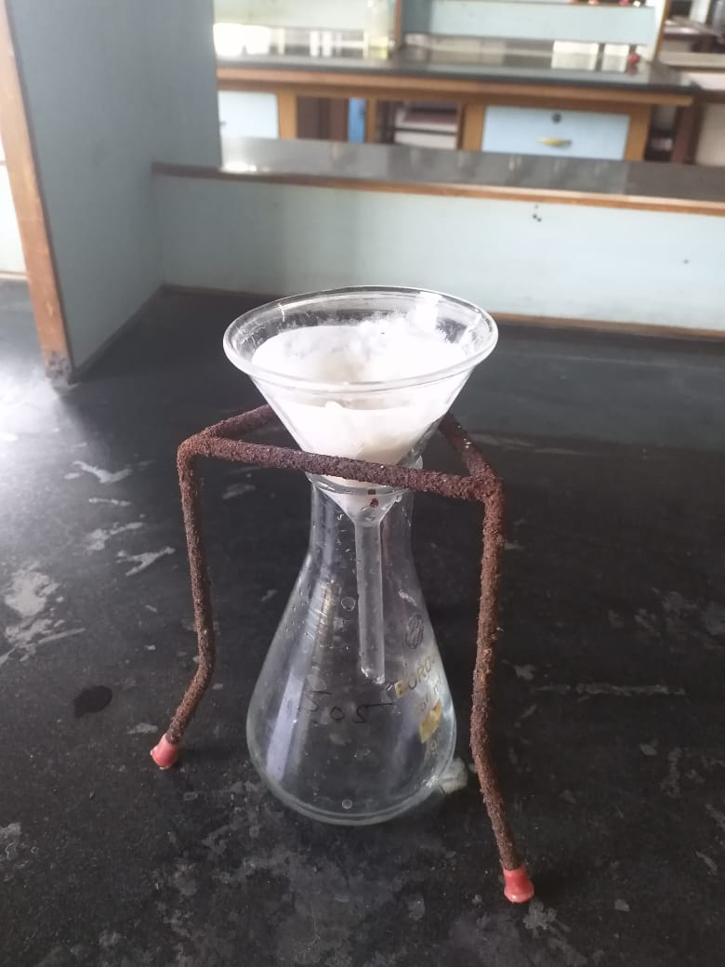

  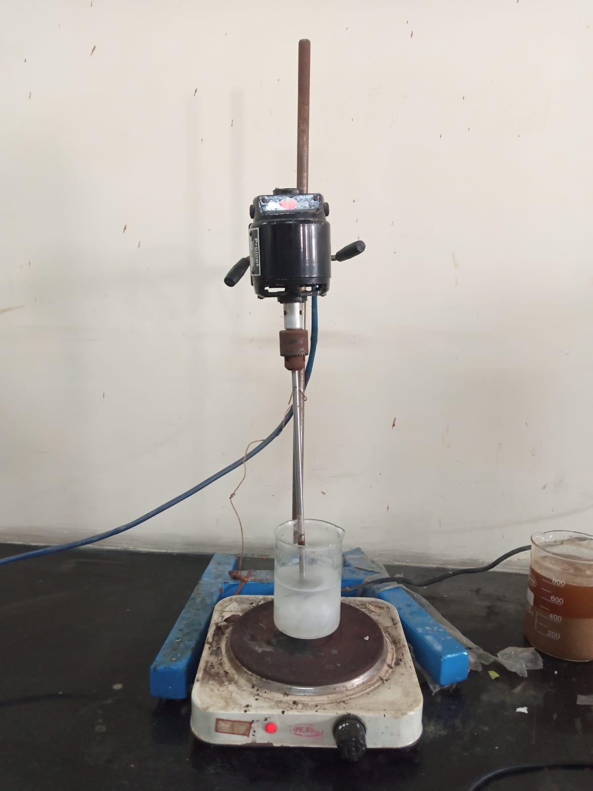

**Drying**  **Filtration** **Alkaline treatment**

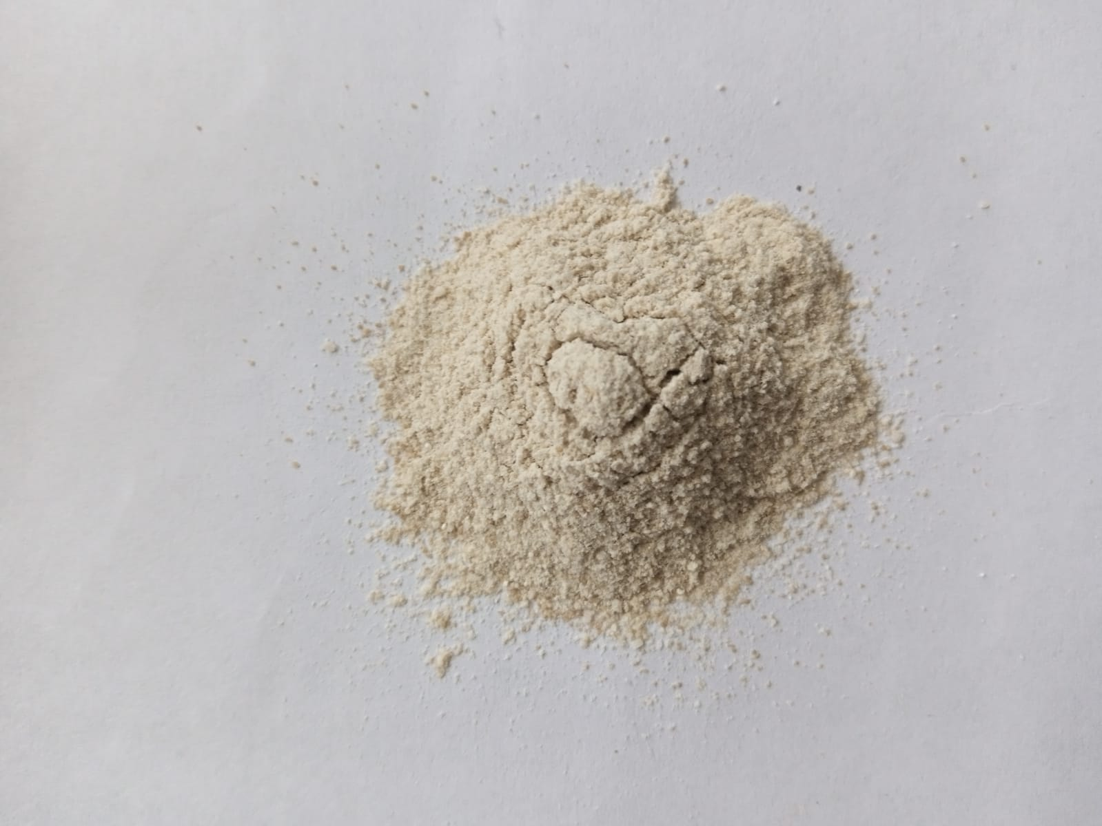

**Nanocellulose powder**

**Cotton Alkali treatment Filtration**

**Figure 2. Flow diagram of isolation of nanocellulose from cotton**

###### 2.2 Preparation of Starch/PVA/Nanocellulose blend film

###### The isolated starch was dissolved in 100 ml of distilled water & the solution was homogenized using mechanical stirrer for 50 minutes. At the same time, heating (700C) was provided using heating mantle. similarly, PVA solution are prepared in 100ml distilled water. Nanocellulose solution (dissolved in 50ml distilled water) was added to PVA/starch solution and stirred for 10 minutes. Later on, 40% wt. of glycerol was added to solution The viscous solution was pouring in petridish and drying in hot air oven for 24hrs at 500C15. The prepared film is shown in figure 3.

###### 

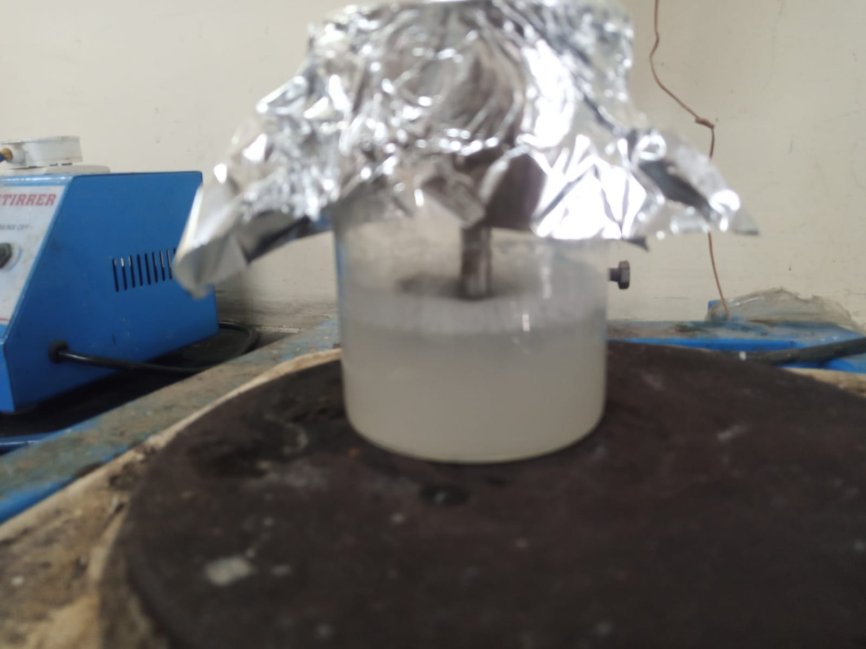 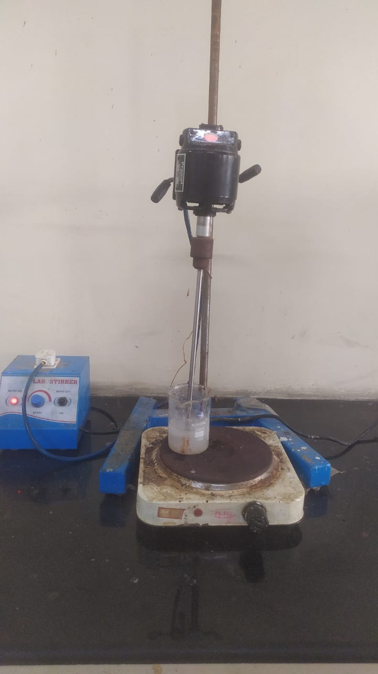 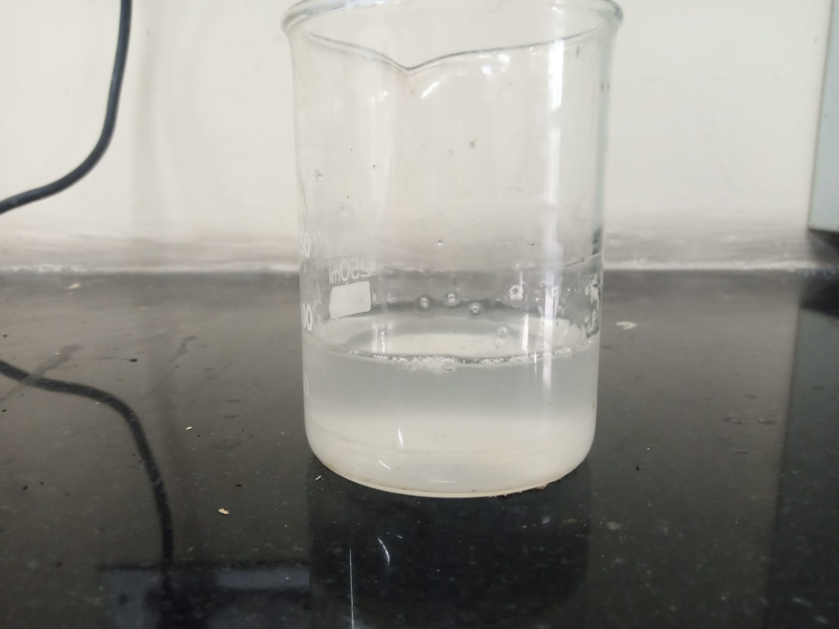

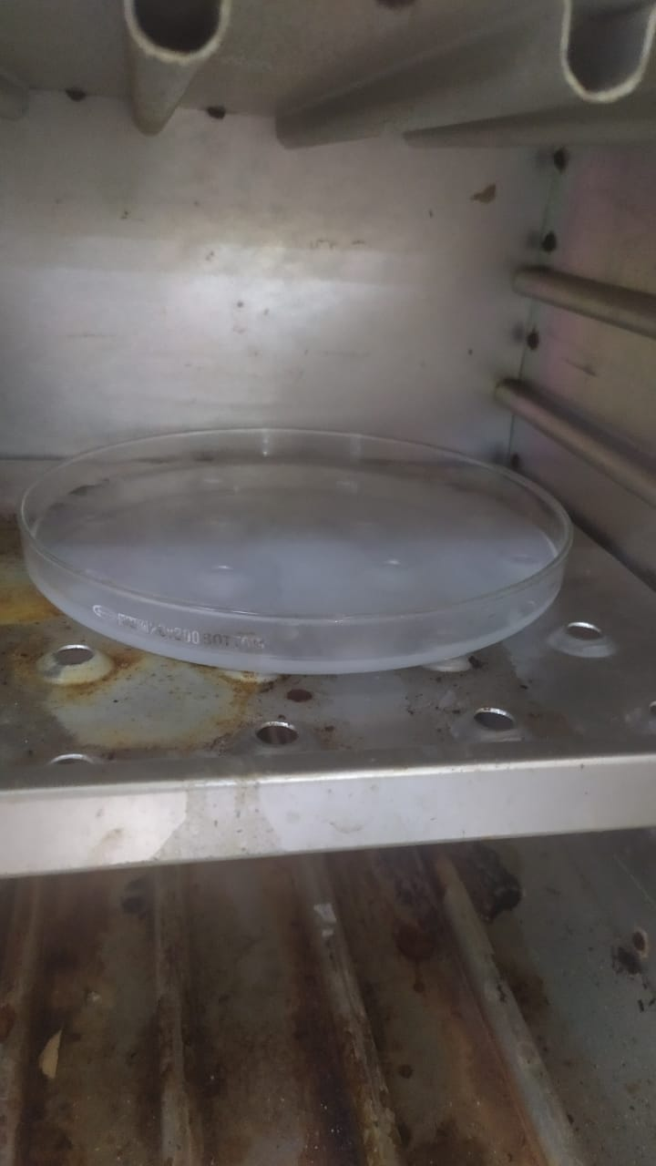

**Drying**

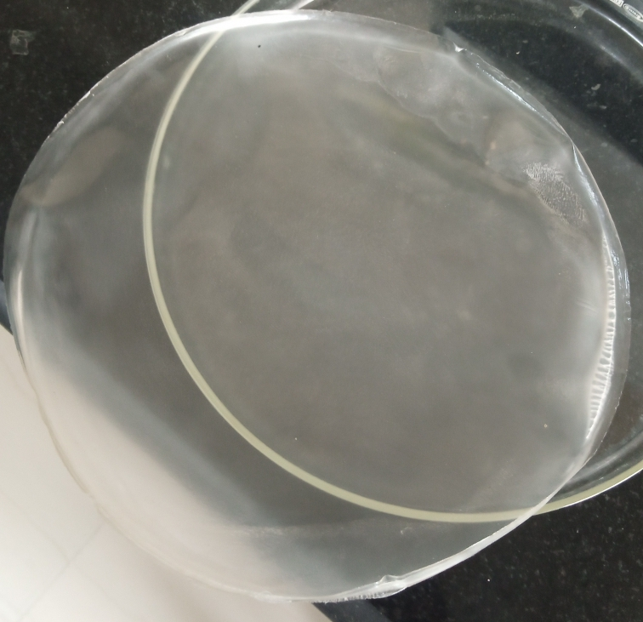 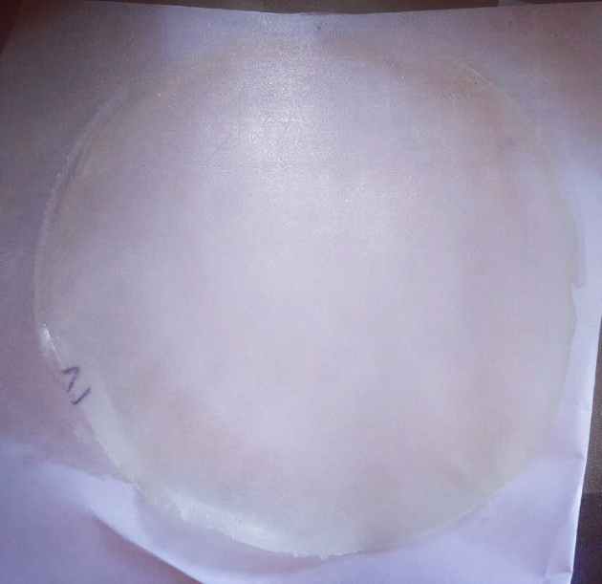 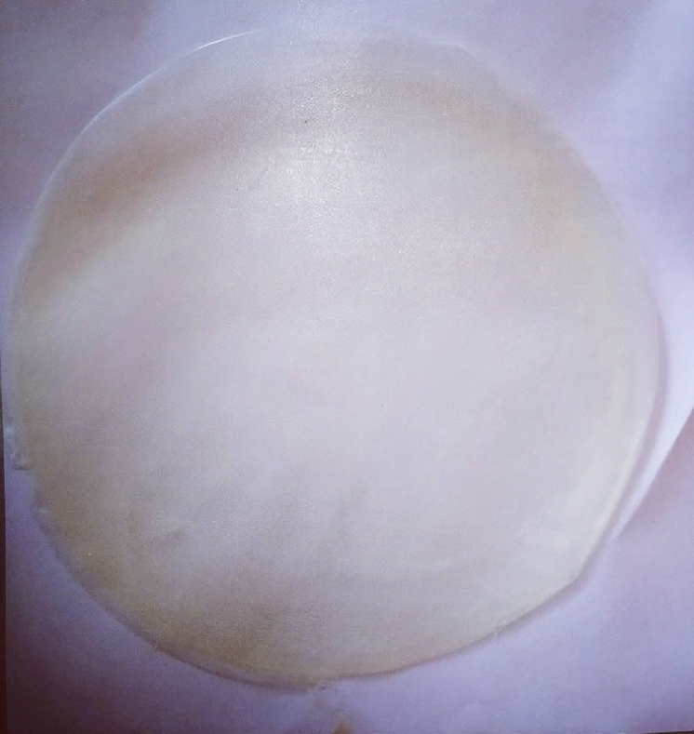 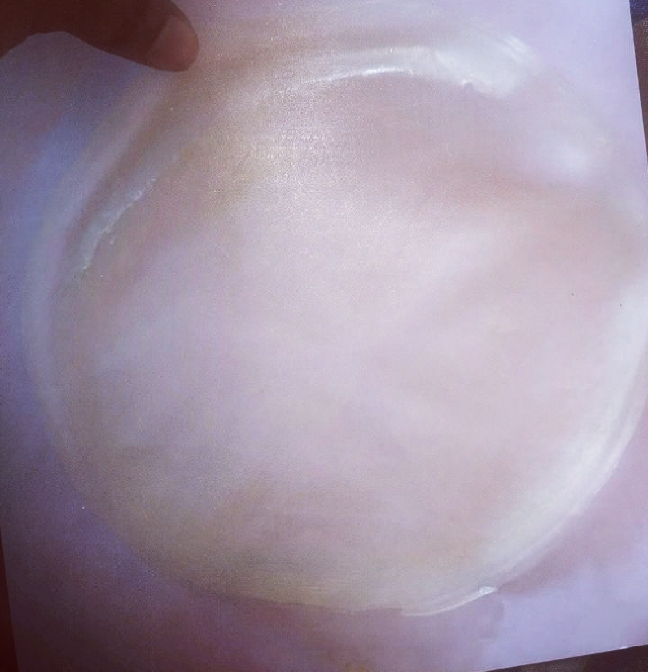

**Starch solution PVA solution Nanocellulose solution**

**SPN-0 SPN-1 SPN-2 SPN-3**

**Figure 3. Prepared Starch/PVA/Nanocellulose blend film**

###### Table 1. Prepared the different compositions of starch/PVA/Nanocellulose film-

|  |  |  |  |  |
| --- | --- | --- | --- | --- |
| **Sample code** | **Starch(wt.%)** | **PVA (wt. %)** | **Nanocellulose**  **(wt.%)** | **Glycerol (wt. %)** |
| SPN-0 | 30 | 70 | 0 | 30 |
| SPN-1 | 30 | 70 | 0.5 | 30 |
| SPN-2 | 30 | 70 | 0.5 | 30 |
| SPN-3 | 30 | 70 | 0.5 | 30 |

**3. Testing and characterization**

**3.1 FTIR**

The FTIR Spectrometer (Thermo- Scientific Nicolet 6700) was used to characterize FTIR spectra of prepared film. The spectrometer operates with in the wavenumber range of 4000-400cm-1

**3.2 SEM**

The morphology of prepared film samples was analyzed by using a SEM (JEOL JSM-6490LV) Japan with the accelerated voltage of 30Kv.

**3.3 Mechanical Properties**

The mechanical properties of prepared film were analyzed by using Universal Instron Tensile testing machine (Model 3382) according to ASTM D882.

**3.4 Optical Properties**

The percentage transmittance of film were measured using Haze meter (Model PTC/089/OP, RDNL ENGLAND) as per ASTM D 1003-07.

**3.5 DSC**

The melting temperature of film were examined using a Perkin Elmer DSC 8000 (USA), from 25 to 250°C at a heating rate of 10°C/min in a nitrogen atmosphere and at 20 mL/min.

**3.6 TGA**

The thermal analysis of keratin in the temperature range 10-800°C was evaluated using Perkin Elmer Pyris 7.TGA (Waltham, Massachusetts USA) at a heating rate of 10°C/min in a nitrogen atmosphere.

3.7 **Water Absorption Test.**

Water absorption test of prepared film were investigated as per ASTM D570.

The given formula below used to calculate water absorption (%).

% Weight of absorption = (Wi – Wf) /(Wf)×100

Where, Wi = Initial weight

Wf = Final weight

**3.8 Biodegradation Test**

For the investigation of the biodegradability of prepared film using soil burial method. In this method the test is investigated in both laboratory & natural conditions. To study the biodegradation of film cut 10×10 cm2 from each sample and placed in pot prepared with compost. The pot is placed in environment for 14days. After the fixed interval of time remove the sample from soil clean and dried in oven. The percentage of weight loss of the specimen was calculated by given formula:

Weight loss = [(A0 – A1)/A0] × 100%

Where,

A0 = Initial weight of film

A1 = Final weight of film

**4. RESULTS AND DISCUSSION**

###### 4.1 Results of Cassava starch (CS) & Nanocellulose

###### 4.1.1Yield

###### The yield percentage of the extracted Cassava starch was found to be 72.5% [18] and Nanocellulose was 55.5% [22].

###### 

###### 4.2 FTIR Analysis of Cassava starch

###### The extracted starch from cassava was characterized by using FTIR, as shown in figure 4. The analysis of functional groups & fingerprint region was done in the range of 4000cm-1 to 450cm-1. A sharp and strong absorption band at 3380.7cm-1 represents the existence of OH group, & also indicates the presence of intramolecular H-bonding. Transmittance at 2930.9cm-1 corresponds to the vibration of C-H stretching. There is a band of stretching (OH) at 1649.3cm-1, which indicates the hygroscopic nature of starch. Band at 1366.7cm-1 indicates the C-H bending vibration and the band between 1010.9cm-1 to 764.2cm-1 is a feature of polysaccharides and is attributed to strain deformation of C-O-C & flexion of OH. The characterization of the extracted starch from cassava by FTIR analysis gave relevant peaks, confirming the quality of starch with minimal impurities16.

**Figure 4. FTIR Spectra of Cassava starch**

**Table 2. FTIR analysis of starch**

|  |  |
| --- | --- |
| **Peaks (cm-1)** | **Functional group** |
| 3380.07 | OH - group |
| 2930.9 | C-H stretching |
| 1649.3 | O-H stretching |
| 1366.7 | C-H bending |
| 1010.9 | C-O-C |
| 746.2 | Flexion of OH |

###### 4.3 Result of Starch/PVA/Nanocellulose blend film

###### 4.3.1 Mechanical Properties

###### The prepare Starch/PVA/Nanocellulose blend film was tested for mechanical properties by using universal testing machine as show in figure 5. Figure shows that there is increase in tensile strength, & tensile modulus (11.38MPa & 13.92MPa) whereas decrease in % elongation @ break (200.0)17. In case of blend film, the properties also positively affected by the nanocellulose. This may be due to the presence of strong hydrogen bonding interaction between the OH- of the starch. The crystalline order of the starch molecules was distributed during gelatinization process, detonated the OH- groups to hydrogen bonds. As a result, chemical bonds of blend film were stronger & more difficult to break. At the same time, when starch concentration gradually increased, the tensile strength decreased due to the higher content of amylopectin, which is branched structure in starch. Since the polymer chains were separated by the branching structure of amylopectin, their hydrogen bonds were weaker. And also at the same time, when the glycerol was loaded with constant weight % ratio (40%), then tensile strength & tensile modulus decreased, but elongation @ break % increased, with increase in concentration of starch. This may be due to greater free-moment space provided by glycerol loading, allowing the glycerol molecules to slide between the amylose-amylopectin chains. This reduces the polymer’s ability to interact with itself to avoid the formation of stiff structures simultaneously, softening the polymer & increases the elasticity of blend film18 shown in table 5.

**Figure 5. tensile strength, tensile modulus, & % elongation @ break of film**

###### Table 3. The data of prepared blend film-

|  |  |  |  |
| --- | --- | --- | --- |
| Samples | **Tensile strength**  **(Mpa)** | **Tensile modulus (Mpa)** | **% Elongation @ break** |
| SPN-0 | 7.00 | 6.62 | 310 |
| SPN-1 | 9.50 | 7.56 | 288.1 |
| SPN-2 | 10.18 | 9.70 | 208.8 |
| SPN-3 | 11.38 | 13.92 | 200 |

###### 4.3.2 Optical properties

###### The prepared Starch/PVA/Nanocellulose blend film was tested for optical properties by using haze meter, as shown in figure 6. shows the luminous %transmittance & haze of different sample with different weight% of Starch /PVA/Nanocellulose with constant weight% ratio of glycerol. (SPN-0) film has showed 81.74% transmittance & haze of 10.80% due to the Semicrystalline nature of PVA. And in case of (SPN-1, SPN-2, SPN-3) blend film, it is clearly observed from figure 5.5. that the % transmittance was found lesser than the (SPN-0) film, with the increase in concentration of nanocellulose19. The luminous% transmittance & haze of (blend films are shown in table 4 .

**Figure 6. luminous % transmittance, & haze of prepared blend film**

**Table 4. The data of luminous %transmittance, & haze of prepared blend film-**

|  |  |  |
| --- | --- | --- |
| **Samples** | **Luminous % transmittance** | **Haze %** |
| SPN-0 | 90.3 | 66.7 |
| SPN-1 | 90.6 | 63.2 |
| SPN-2 | 88.4 | 64.8 |
| SPN-3 | 85.6 | 62.0 |

###### 4.3.3 Water absorption test

###### The prepared Starch/PVA/Nanocellulose blend film was analysed through water absorption test. It is clearly observed that (SPN-0) film showed higher water absorption%, but decreased gently with gradual increase in the Nanocellulose concentration. This is due to the network structure between the nanocellulose particles and PVA/starch components, which stopped water molecules from dissolving and improved the film's water resistance, was one possible explanation for this type of behaviour20. The addition of nanocellulose fibres alters the channel for water molecules into the film from direct diffusion to a circuitous path, resulting in improved water barrier qualities observed in figure 7. The water absorption% of chitosan and its blend film is shown in table 5 .

**Figure 7. Water absorption % of prepared blend film**

**Table 5. The data of water absorption% of blend film-**

|  |  |
| --- | --- |
| **Samples** | **Water absorption%** |
| SPN-0 | 42.2 |
| SPN-1 | 40.00 |
| SPN-2 | 36.9 |
| SPN-3 | 32.8 |

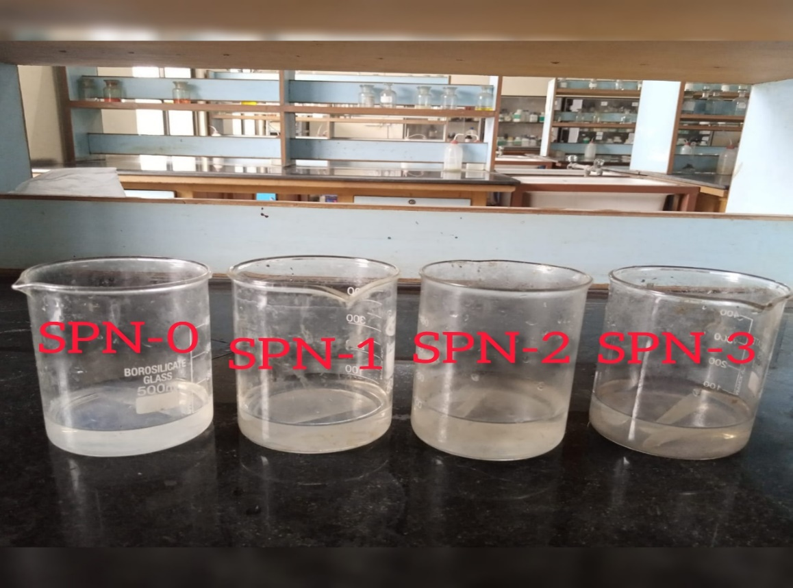

**Figure 8. Water absorption test of blend film**

###### 4.3.4 Biodegradability test (Soil Burial Method)

###### The weight loss of the prepared sample was also investigated after 14 days as shown in figure 9. of different sample respectively. It is observed that SPN-0 sample degraded slowly show less weight. loss as compared to other samples due to the addition of nanocellulose. It is naturally occurring polymer that are highly susceptible to microbial attack as a result the blended film degrade at higher rate than neat PVA/starch film21. The weight loss% of sample. It is investigated through data shown in table 6 that when weight% of starch/nanocellulose increases there is a significant effect was found in the biodegradation of prepared film.

**Figure 9. Weight loss after soil burial test for 14 days of prepared blend film**

**Table 6. The data of weight% loss of blend film after 14days soil burial test-**

|  |  |
| --- | --- |
| **Samples** | **Weight loss (%)** |
| SPN-0 | 25.30 |
| SPN-1 | 27.12 |
| SPN-2 | 31.22 |
| SPN-3 | 36.50 |

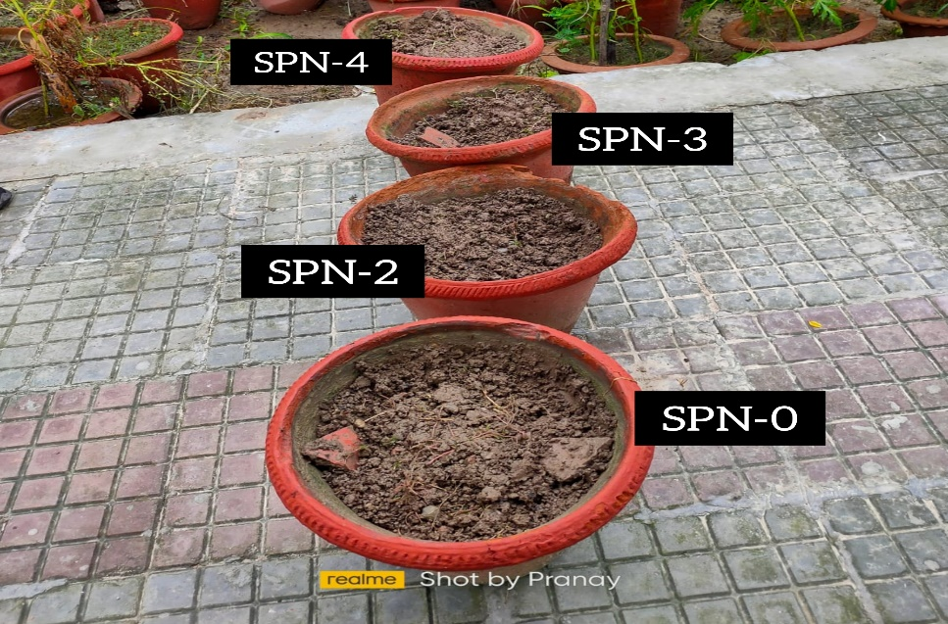

**Figure 10. The sample soil burial test for 14 days**

###### 4.3.5 FTIR analysis of (Starch/PVA/Nanocellulose) blend film

###### The starch/PVA/Nanocellulose blend film was characterized by using FTIR, as shown in figure 11. The analysis of functional groups & fingerprint region was done in the range of 4000cm-1 to 450cm-1. The IR spectra of blend film showed peaks at 1040.0cm-1, & 1157.1cm-1 which are characteristics of a polysaccharide (due to C-O stretching, O-H bending, & C-N stretching). The O-H stretching was found at 1630.8cm-1, due to the interaction between nanocellulose & hydroxyl group of starch. The bands near 1412.8cm-1 was characterized as corresponding to the CH2 group. The peak at 2930.0cm-1 is attributed to the C-H stretching. The O-H stretching, which overlaps the N-H stretching, due to the inter & intra-molecular hydrogen bond was shifted at 3400.1cm-1. And the bands from 670.0cm-1 to 919.6cm-1 corresponds to C=C bending & C-H bend. Changes in typical spectrum peaks represent chemical interactions. These results showed good compatibility & interaction between the (starch/pva/nanocellulose) blend film22.

**Figure 11. FTIR analysis of (CS) blend film**

###### 4.3.6 SEM Analysis of (SPN-0) & (SPN-2) blend film

###### The scanning electron microscope of (SPN-0) & (SPN-2) blend film is shown in figure 12 & 13 at different magnification of 50x, 100x, 200x, 500x and result obtained that the SEM image of SPN-0 film have a surface that is homogeneous & smooth, with very sparsely distributed small particles & found no signs of any phase separation. And also, in (SPN-2) blend film. After addition of nanocellulose in starch/PVA there is a crack propagation on the surface of film. Also, there is a good interfacial adhesion exists between two components of the (CS) blend film23.





**50X**

**100X**





**500X**

**200X**

**Figure 12. SEM images of prepared (SPN-0) blend film**

 

**50X 100X**

 

**200X 500X**

**Figure 13. SEM images of prepared (SPN-2) blend film**

###### 4.3.7 DSC Analysis of (SPN-0) film, & (SPN-2) blend film

###### The differential scanning calorimetry was performed at a heating rate of 100C/minute for the samples (SPN-0 & SPN-2) as shown in figure 5.12. the result obtained that the blend film exhibited separate reaction zones. The endothermic peak, which appeared in all the film samples, are associated with the evaporation of water in the films & occurs between 1000C to 1300C in the first run. The starch/PVA film (SPN-0) transition was observed at 190.720C similarly in (SPN-2), the transition at 207.72°C. Tg was not seen in both due to, when starch was added as a filler, which is semi-crystalline in nature with glycerol, which is act as a plasticizer which reduced the intermolecular interactions between polymer chains, which decrease overall cohesiveness & bring the Tg down to or below room temperature. The dissolution of the polymer, including the dehydration of Polysaccharide rings, depolymerization, & decomposition of hydroxyl group of PVA24 could be attributed to a high & broad exothermic peak as observed in figure 14. also, the data show in table 7.

**Table 7. The data of (SPN-0) film, & (SPN-2) blend film-**

|  |  |  |  |
| --- | --- | --- | --- |
| **S. No.** | **Samples** | **Exothermic peaks Tm (0C)** | **Enthalpy (J/g)** |
| **1-** | SPN-0 | 190.720C | 53.52 |
| **2-** | SPN-2 | 207.720C | 54.59 |

**207.72°C**

**Figure 1.12: DSC graph of (SPN-0) & (SPN-2) blend film**

**Figure 14 DSC graph of (SPN-O) & (SPN-2) blend film**

**4.3.8 TGA Analysis of (SPN-0) & (SPN-2) blend film**

The Thermogravimetric analysis was done under the nitrogen atmosphere at temperature up to 600°C, & the test was performed at heating rate of 10°C/minute. The thermal degradation of (SPN-0) & (SPN-2) are shown in figure 15. It was found the thermal degradation of film occurs in three phases. The first weight loss of (SPN-0) & (SPN-2) blend film was found at temperature range between 119.40°C, & 134.20°C This mass loss was due to the evaporation of water. While the second weight loss of the temperature range between 186.88°C and 206.22°C respectively. This is due to the complex process including the depolymerisation & break down of hydroxyl chain unit. In comparison to PVA, the thermal decomposition temperature of blend films changed to slightly higher temperature with increase in nanocellulose concentration25. And the third weight loss of blend film the temperature range between 312.20°C, & 352.57°C, these higher weight losses started above 350°C, due to unsaturated molecular structure of starch, & the remaining residue was inorganic as a result of the pyrolysis of carbonated chemicals26.

**Table 8. Data of (SPN-0) & (SPN-2) blend film-**

|  |  |  |  |
| --- | --- | --- | --- |
| **Samples** | **5% wt. loss (°C)** | **10% wt. loss (°C)** | **50% wt. loss (°C)** |
| SPN-0 | 119.400C | 186.88 | 312.20 |
| SPN-2 | 134.200C | 206.22 | 352.57 |

**Figure 15. TGA analysis of prepared (SPN-O & SPN-2) blend film**

###### 5. Conclusion

###### Starch from cassava was successfully extracted. The extracted starch showed 29.5% yield, The extracted starch was characterized using FTIR. The strong absorption band of hydroxyl group (OH) at 3380.7cm-1, peak at 1649.33cm-1 showed hygroscopic nature of starch, & band between 1010.09cm-1 to 768.74cm-1 showed features of polysaccharides. Further Nanocellulose from waste cotton was successfully extracted. The isolated nanocellulose showed 55.5% yield. The isolated starch from cassava and Nanocellulose was blended with Polyvinyl alcohol & analysed the effect of extracted nanocellulose on the particular blend film. The Nanocellulose was added different weight % ratio of 0%, 0.5%, 1.0%, 1.5% & varying starch weight% ratio of 0%, 1%, 2%, 4% respectively with constant weight% ratio 40% of glycerol. The mechanical properties were analysed by UTM machine like tensile strength, tensile modulus of the blend film increases whereas elongation @ break% decreasing as compared to virgin film. The luminous% transmittance of blend film decreased with increase in haze as compared to virgin film. The blend film showed hydrophobic nature & The biodegradability test analysed by soil burial method & it was found that weight% loss was higher in case of blend film as compared to virgin film. The functional groups & fingerprint region was analysed by using. FTIR. The O-H stretching overlapped the N-H stretching & peak was shifted to 3400.1cm-1. due to the interaction between nanocellulose & hydroxyl group of PVA & peaks at 1040.0cm-1 & 1157.1cm-1 showed characteristics of saccharides. The morphology of blend film & virgin film analysed by using SEM, which confirmed the surface was homogeneous, smooth & no any phase separation in case blend film & in virgin film, also sparsely distributed small particles of starch in blend film. Thermal analysis by using DSC, SPN-2 blend film highest exothermic peak found at 207.720C. TGA showed the sample (SPN-2) had best result with highest thermal stability. From the above it was found best result of mechanical properties, optical properties, water absorption & biodegradability test, & also showed good miscibility& surface morphology between Starch/PVA/Nanocellulose. The results obtained from this study shows that the prepared blend film can be used for packaging application.

**REFERENCES**

1. Michael Niaounakis. “Biopolymers: Applications and Trends.” PDL Handbook Series (2015).
2. R.M. Johnson, L.Y. Mwaikambo, N. Tucker. “Biopolymers.” Rapra review reports, Vol. 14, No. 3 (2003).
3. Richard F. Tester, John Karkalas, Xin Qi. “Starch-composition, fine structure and architecture.” Journal of Cereal Science 39 (2004): 151-165.
4. Jean-Luc Putaux, Sonia Molina-Boisseau, Thomas Momaur, Alain Dufresne. “Platelet nanocrystals resulting from the disruption of waxy maize starch granules by acid hydrolysis.” Biomacromolecules 4 (2003): 1198-1202.
5. Denis Lourdin, Guy Della Valle, Paul Colonna. “Influence of amylose content on starch films and foams.” Carbohydrate Polymers 27.4 (1995): 261-270.
6. Paivi Myllarinen. “Starches-from granules to novel applications.” ESPOO, Technical Research of Finland, VTT Publications 473 (2002).
7. Henderson R., Clapperton, Henderson W. “Modern paper-making.” Oxford: Basil Blackwell, Edition 3rd,120 (1947).
8. RA Schutz. “Theoretical and practical aspects of sizing today and tomorrow.” 3rd International Sizing Symposium (1977).
9. Li, Shi, Bosheng Zheng. “Sizing processing discussion of PR-Su size mixture replacing PVA[J].” Cotton Textile Technology 6:012 (2008).
10. James N. BeMiller. “Starch modification: challenges and prospects.” Starch/Starke 49 (1997): 127-131.
11. JM Light. “Modified food starches: why, what, where and how.” 74th AACC’s annual meeting Washington DC (1989).
12. Haq Nawaz, Rashen Waheed, Mubashir Nawaz, Dure Shahwar. “Physical and chemical modifications in starch structure and reactivity.” Chemical properties of starch (2020).
13. F.H. Steiger. “Surgical dressing.” US 3241553 (1966).
14. Tayser Sumer Gaaz, Abu Bakar Sulong, Majid Niaz Akhtar, Abdul Amir H. Kadhum, Abu Bakar Mohamad, Ahmed A. Al-Amiery. “Properties and applications of Polyvinyl Alcohol, halloysite nanotubes and their nanocomposites.” Molecules 20 (2015), 22833-22847.
15. Sonam Chaurasia, Aditya Lal. “Development of Biodegradable Packaging Film using Potato Starch.” International Journal of Current Engineering and Technology Vol.6, No.3 (2016).
16. Sraboni Kundu, Tanvir Muslim, Md. Azizur Rahman, Md. Al-Amin Faisal. “Extraction of starch from different sources: their modification and evaluation of properties as pharmaceutical excipient.” Dhaka Univ. J. Sci. 59(2) (2011): 263- 266.
17. Madsar Hameed, Shahid Raza Malik, Muhammad Farhan Iqbal, Muzammil Mehmood. “Extraction od starch from potato by enzymatic process.” Sci. Int. 27(6) (2015): 6049-6052
18. Sharmila Patil, Ashok Kumar Bharimalla, Archana Mahapatra, Jyoti Dhakane- Lad, A. Arputharaj, Manoj Kumar, A.S.M. Raja, Nishant Kambli. “Effect of polymer blending on mechanical and barrier properties of starch-polyvinyl alcohol based biodegradable composite films.” Food Bioscience 44 (2021): 101352
19. Pavan Kumar Dara, Mahadevan R., Sivaraman G. K., Karthik Deekonda, Visnuvinayagam S., Pnandan Rangasamy, Suseela Mathew, Ravishankar C. N. “Biomodulation of poly (vinyl alcohol)/starch polymers into composite-based hybridised films: physico-chemical, structural and biocompatibility characterization.” Journal of Polymer Research 28 (2021): 265.
20. Fahmida Parvin, Md. Arifur Rahman, Jahid M. M. Islam, Dr. Mubarak A. Khan,
21. H. M. Saadat. “Preparation and Characterization of Starch/PVA Blend for Biodegradable Packaging Material.” Advanced Materials Research Vols. 123-125 (2010): 351-354.
22. Bingnan Mu, Lan Xu, Yiqi Yang. “Flexible and wet stable starch films crosslinked with sugar-based aldehydes.” Industrial Crops & Products 173 (2021): 114109.
23. Preetha Balakrishnan, Sreekala M. S., Geethamma V.G., Nandakumar Kalarikkal, Vanja Kokol, Tatiana Volova, Sabu Thomas. “Physicochemical mechanical barrier and antibacterial properties of Starch nanocomposites crosslinked with pre-oxidized sucrose.”, Industrial Crops & Products 130 (2019): 398-408.
24. F. G. Nugroho, N. M. Nizardo, E. Saepudin. “Synthesis of citric acid crosslinked PVA/tapioca starch bioplastic reinforced with grafted cellulose.” AIP Publishing (2020).
25. Nedim Gurler, Salih Pasa, Hamdi Temel, “Silane doped biodegradable starch – PLA bilayer films for food packaging applications: Mechanical, thermal, barrier and biodegradability properties.” Journal of the Taiwan Institute of Chemical Engineers 000 (2021): 1-11.
26. Narendra Reddy, Yiqi Yang. “Citric acid cross-linking of starch films.” Food Chemistry 118.3 (2009): 702-711.